I have continued coding until it has reached an error free state. I did notice that since I was heavily confused on termination point for the do while.
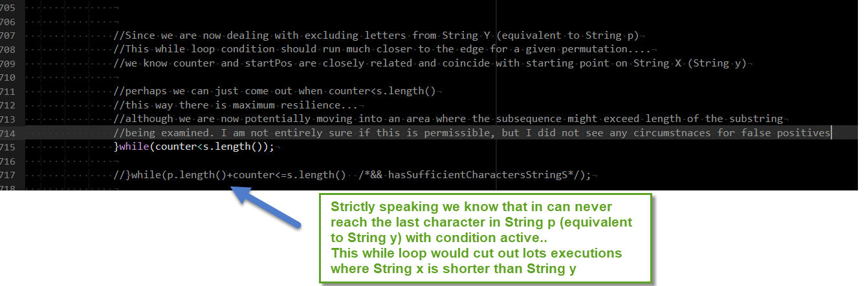

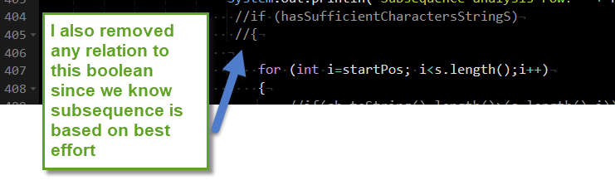
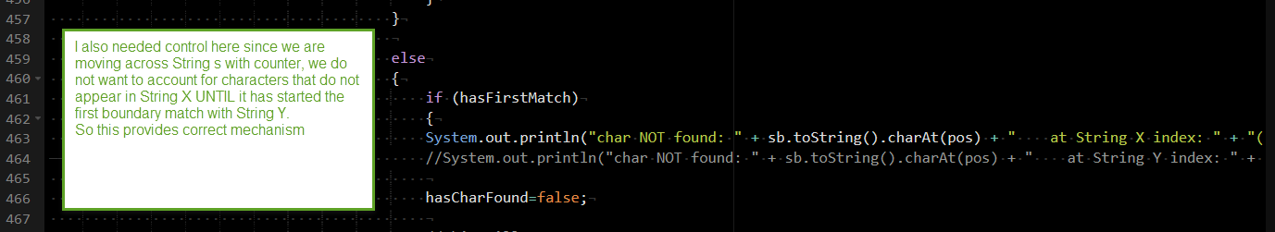

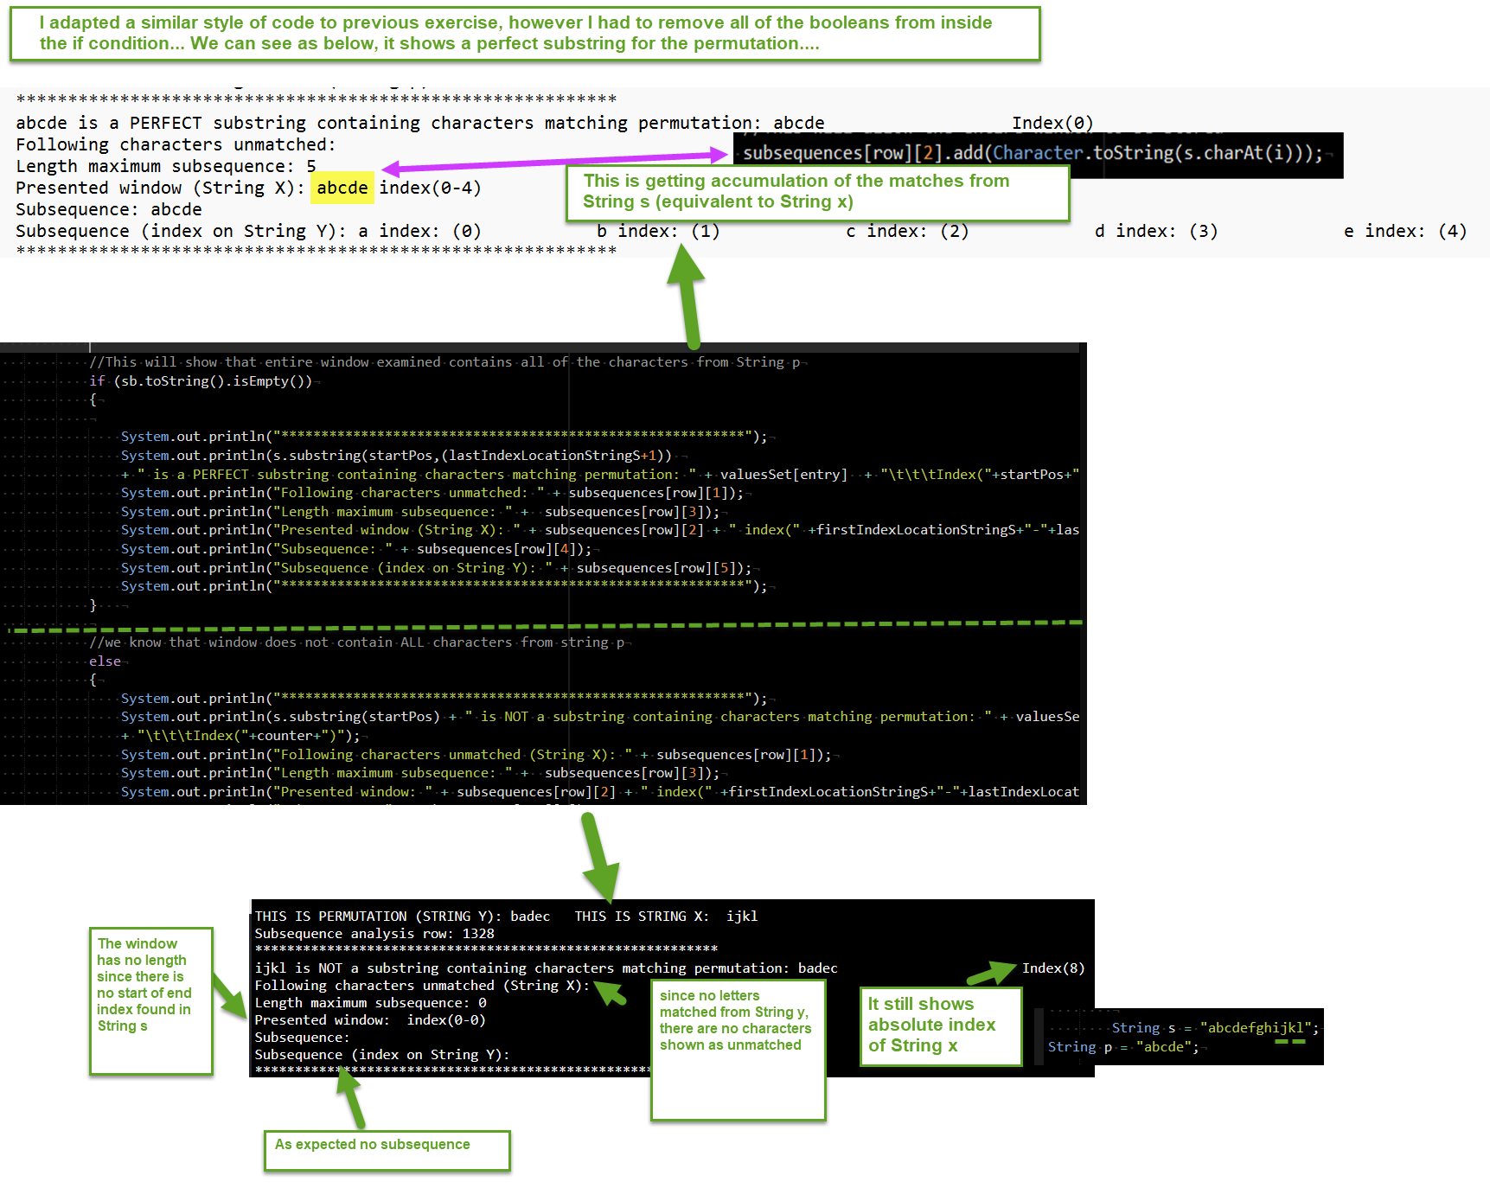

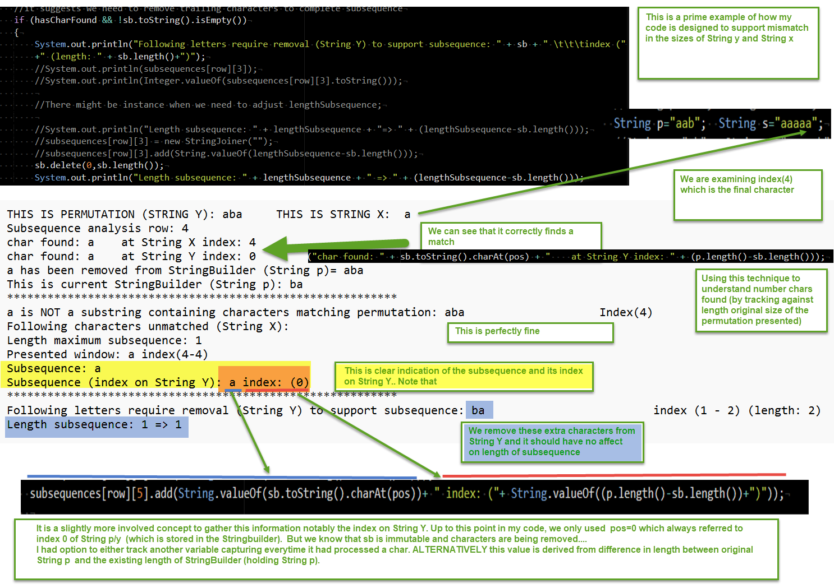
CHATGPT CONVERSATION
in subsequences, can string p be shorter than string s
Yes — and that’s the normal case.
Subsequence basics
A string p is a subsequence of s if you can delete some characters from s (without reordering the remaining ones) and get p.
So for p to be a subsequence of s, you must have:
- len(p) ≤ len(s)
If len(p) > len(s), then p cannot be a subsequence of s.
Examples
- p="ace" is a subsequence of s="abcde" (take a,c,e).
- p="abc" is not a subsequence of s="acb" (order doesn’t work).
- p="abcd" cannot be a subsequence of s="abc" (too long).
If you meant your other setup (delete from p to make it appear in s), then even if p is longer than s, you can still delete from p until the remaining subsequence fits inside s.

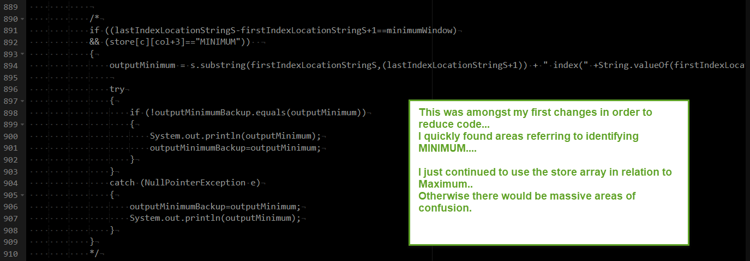

With all this extreme hard effort, I was at a point where the single test case was failing…
I particularly found this a scenario which would be extremely difficult to isolate.
It is reminiscent of level of issues I encountered on several challenges in which there was a mismatch between mid-execution and summary at the end.
Here is the exact test case:
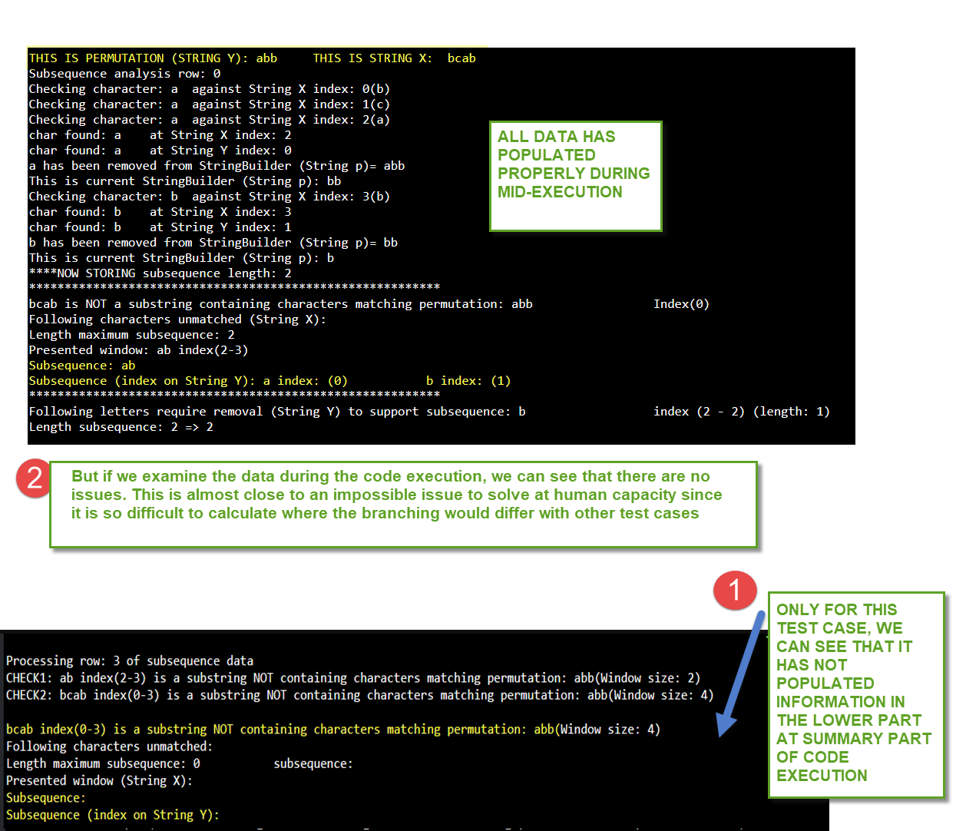

I have let ChatGPT examine my code for the first time.
Once again, one or two were human errors which I might have noticed if I tidied my code.
But there were several changes….
Note, some modifications with the usual ------------chatGPT-------------
------------end ChatGPT---------
are the modifications from the inclusion of String p in String s
I will go through each of the inputs by ChatGPT to demonstrate my understanding. As per aforementioned, it is logic which does not resonate with me.
CHATGPT CHANGE (I consider this as highly unavoidable)
You’ve basically already found the root cause in your own logs:
- Your debug trace shows you successfully matched a (index 0 in String Y) and b (index 1 in String Y) for permutation abb inside bcab.
- So the maximum subsequence length should be 2 and the subsequence should be ab.
The reason your final “subsequence” section ends up showing length 0 / empty subsequence is because in your uploaded file Main(192).java, the variable:
int lengthSubsequence=0;
is never updated anywhere before you store it into:
subsequences[row][3].add(String.valueOf(lengthSubsequence));
So it stores 0, and your final summary prints 0 / blank even though the match logic worked.

Minimal fix (1 line of logic + comments)
Right before this line:
System.out.println("****NOW STORING subsequence length: " + lengthSubsequence);
set:
lengthSubsequence = p.length() - sb.length();
Why this works:
- You delete one char from sb every time you find a match.
- So p.length() - sb.length() = number of matched characters = matchedLength.

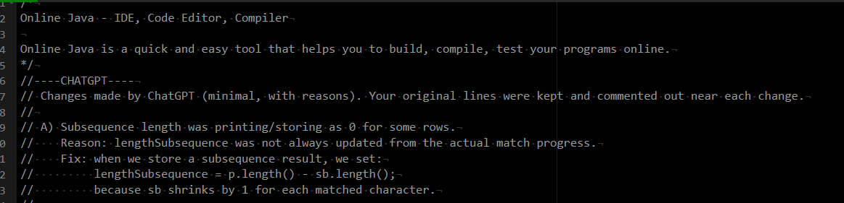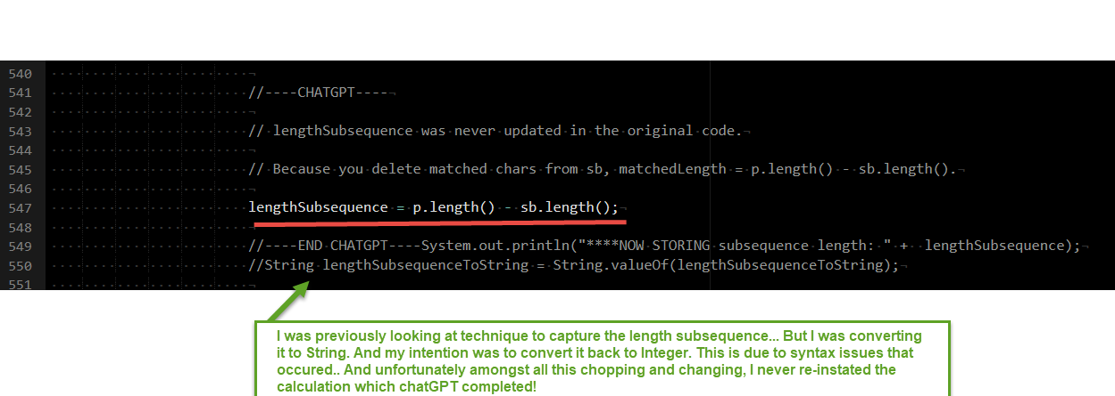

CHATGPT CHANGE (I ALSO CONSIDER THIS AS HIGHLY UNAVOIDABLE)
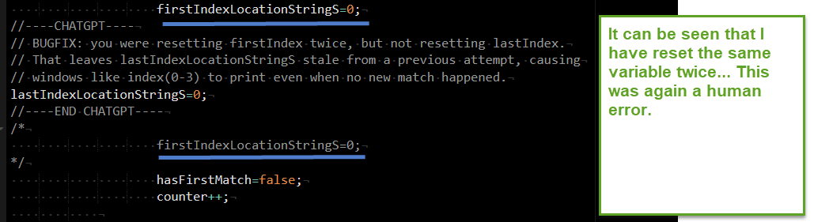
In my previous challenge, same error transpired.
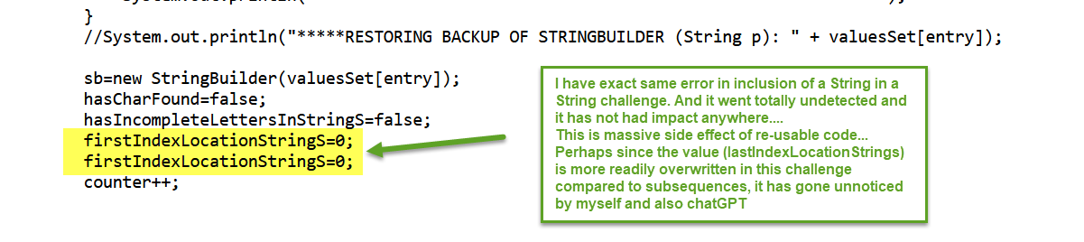
CHATGPT CHANGE (I CONSIDER THIS AS TECHNICAL CHANGE)
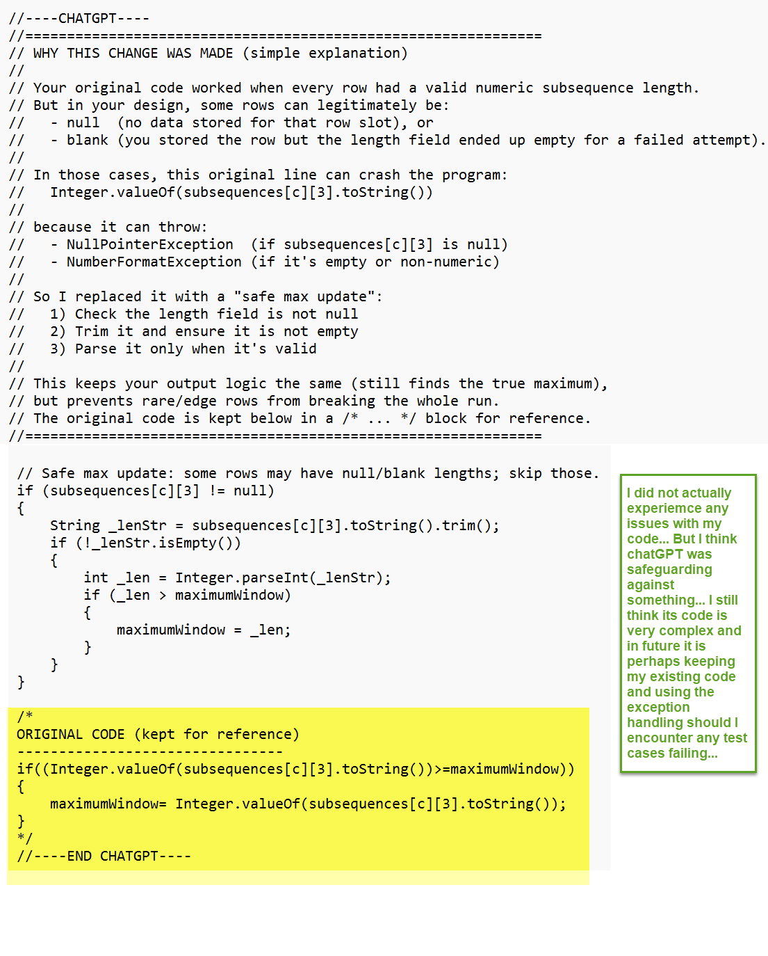
So my immediate response was to ask ChatGPT on test cases in which my existing code (yellow) would cause exceptions…
An option for me is to remove its code and re-instate mine:
CHATGPT CONVERSATION
could you provide test cases that would give exception (if I kept my code active instead of yours)
Yes — your original max-update line can throw NullPointerException or NumberFormatException depending on what ends up in subsequences[c][3].
Your original code:
if((Integer.valueOf(subsequences[c][3].toString())>=maximumWindow))
{
maximumWindow= Integer.valueOf(subsequences[c][3].toString());
}
When it breaks
- NullPointerException if subsequences[c][3] == null
- NumberFormatException if subsequences[c][3].toString() is "", " ", "\n", etc.
Because your program stores rows for “not containing permutation” attempts and some of those rows can end up with length not populated (depending on branch/early exit), these situations happen on certain inputs.

Test case set that commonly creates null/blank length rows
1) No character of p exists in s (lots of “0 match” attempts)
String p = "abc";
String s = "zzzzzz";
Why it can break:
- Many attempts never match anything.
- Depending on your branch logic, you may still create a row but never add a length → subsequences[row][3] stays null or empty.
2) s is shorter than p (your subsequence logic stores “failed” rows)
String p = "abcd";
String s = "ab";
Why it can break:
- You terminate attempts early due to insufficient characters.
- Some branches print debug but don’t store a numeric length string.
3) p has repeats, s has only one occurrence (partial matches + early termination)
String p = "aaab";
String s = "a";
Why it can break:
- You match at most 1 char.
- Some permutations/attempts can produce blank length if the “store length” line is not executed on that path.
4) Empty-ish s (fast failure paths)
String p = "ab";
String s = "";
Why it can break:
- Your code likely exits earlier in some paths; any partially initialised row can leave length null/blank.
(If your code blocks empty s earlier, use s=" " or s="x".)

A more “realistic” reproducer based on your earlier style
This one tends to generate a mix of:
- good subsequences
- and rows where some fields were never written (depending on startPos)
String p = "abb";
String s = "bcab"; // you’ve already seen mixed outcomes here
If any row is created but subsequences[c][3] isn’t populated in one branch, your original max-update line will fail.

How to force the exception quickly (if you want proof)
If you temporarily add one debug line right before your original max-update loop:
System.out.println("DEBUG len raw = [" + subsequences[c][3] + "]");
and you see:
- DEBUG len raw = [null] → original code will throw NullPointerException
- DEBUG len raw = [] or [ ] → original code will throw NumberFormatException

If you tell me what your current p/s are in the run where you saw “Length maximum subsequence: 0” with blank fields, I can point to the exact branch that leaves subsequences[row][3] empty and give you the smallest possible test case that triggers it every time.

